Java Problemsheet - 7

Name: Kaaviya S S Roll. no: 22PT15

1. Write a program to illustrate creation of threads using Runnable interface (start method start each of the newly created thread. Inside the runmethod there is sleep( ) for suspend the thread for 500 milliseconds).

import java.lang.Thread;

class MyRunnable implements Runnable
{
@Override
public void run() {
try {
System.out.println("Thread - " + Thread.currentThread().getName() + " running");
Thread.sleep(500);
System.out.println("Thread - " + Thread.currentThread().getName() + " came out from suspended state");
}
catch (InterruptedException e) {
System.out.println("Thread - " + Thread.currentThread().getName() + " is interrupted");
}
}
}

public class MyRunnableInterface
{
public static void main(String[] args) {
for(int i=0; i<5; i++)
{
MyRunnable runnable = new MyRunnable();
Thread thread = new Thread(runnable, "Thread - " + (i+1));
thread.start();
}
}
}

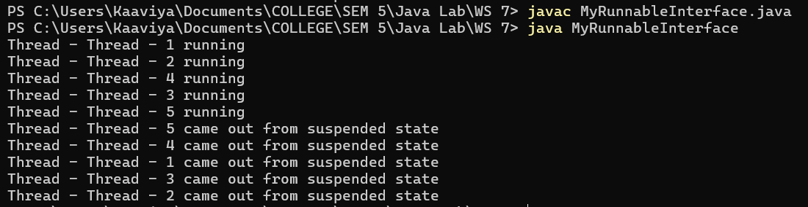

—----------------------------------------------------------------------------------------------------------------------------

2. Write a program to create a class MyThread in this class a constructor, call the base class constructor, using super and starts the thread. The run method of the class starts after this. It can be observed that both mainthread and created child thread are executed concurrently.

import java.lang.Thread;

class MyThread extends Thread
{
public MyThread(String name) {
super(name);
}

@Override
public void run() {
for(int i=0; i<5; i++)
{
System.out.println(this.getName() + " is Executing: " + i);
try {
Thread.sleep(1000);
} catch (InterruptedException e) {
System.out.println(this.getName() + " is interrupted");
}
}
System.out.println(this.getName() + " has finished executing!");
}
}

public class MainThread
{
public static void main(String[] args)
{
MyThread t = new MyThread("Child thread");
t.start();

//main thread
for(int i=0; i<5; i++)
{
System.out.println("Main thread is Executing: " + i);
try {
Thread.sleep(1000);
} catch (InterruptedException e) {
System.out.println("Main thread is interrupted");
}
}
System.out.println("Main thread has finished executing!");
}
}

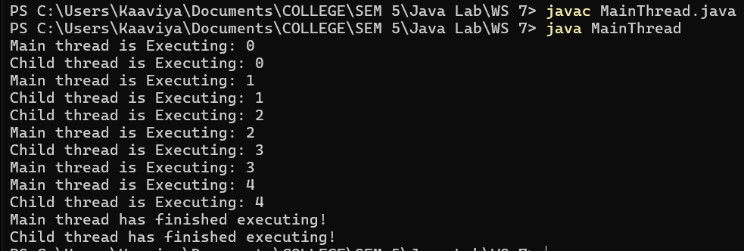

—----------------------------------------------------------------------------------------------------------------------------

3. Write a java program to create five threads with different priorities. Send two threads of highest priority in sleep state. Check the aliveness of the threads and mark which thread is long listing.

import java.lang.Thread;

class MyThreadPriority extends Thread
{
public MyThreadPriority(String name, int priority) {
super(name);
this.setPriority(priority);
this.start();
}

@Override
public void run() {
System.out.println(getName() + " is running with priority " + getPriority());
try {
if (getPriority() == Thread.MAX_PRIORITY) {
System.out.println(getName() + " is sleeping...");
Thread.sleep(2000);
}
}
catch (InterruptedException e) {
System.out.println(this.getName() + " is interrupted");
}
System.out.println(this.getName() + " has finished executing!");
}
}

public class ThreadPriority
{
public static void main(String[] args)
{
// Create 5 threads with different priorities
MyThreadPriority t1 = new MyThreadPriority("Thread 1", Thread.MIN_PRIORITY);
MyThreadPriority t2 = new MyThreadPriority("Thread 2", Thread.MIN_PRIORITY);
MyThreadPriority t3 = new MyThreadPriority("Thread 3", Thread.NORM_PRIORITY);
MyThreadPriority t4 = new MyThreadPriority("Thread 4", Thread.MAX_PRIORITY);
MyThreadPriority t5 = new MyThreadPriority("Thread 5", Thread.MAX_PRIORITY);

while (true)
{
if (!t1.isAlive() && !t2.isAlive() && !t3.isAlive() && !t4.isAlive() && !t5.isAlive()) {
break;
}

System.out.println("\nChecking thread aliveness:");
System.out.println("Is " + t1.getName() + " alive? " + t1.isAlive());
System.out.println("Is " + t2.getName() + " alive? " + t2.isAlive());
System.out.println("Is " + t3.getName() + " alive? " + t3.isAlive());
System.out.println("Is " + t4.getName() + " alive? " + t4.isAlive());
System.out.println("Is " + t5.getName() + " alive? " + t5.isAlive());

if (t4.isAlive() || t5.isAlive()) {
System.out.println( (t4.isAlive() ? t4.getName() : t5.getName()) + " is long-lasting.");
}

try {
Thread.sleep(1000); // Check every second
} catch (InterruptedException e) {
System.out.println(e);
}
}

System.out.println("All threads have finished execution.");

}
}

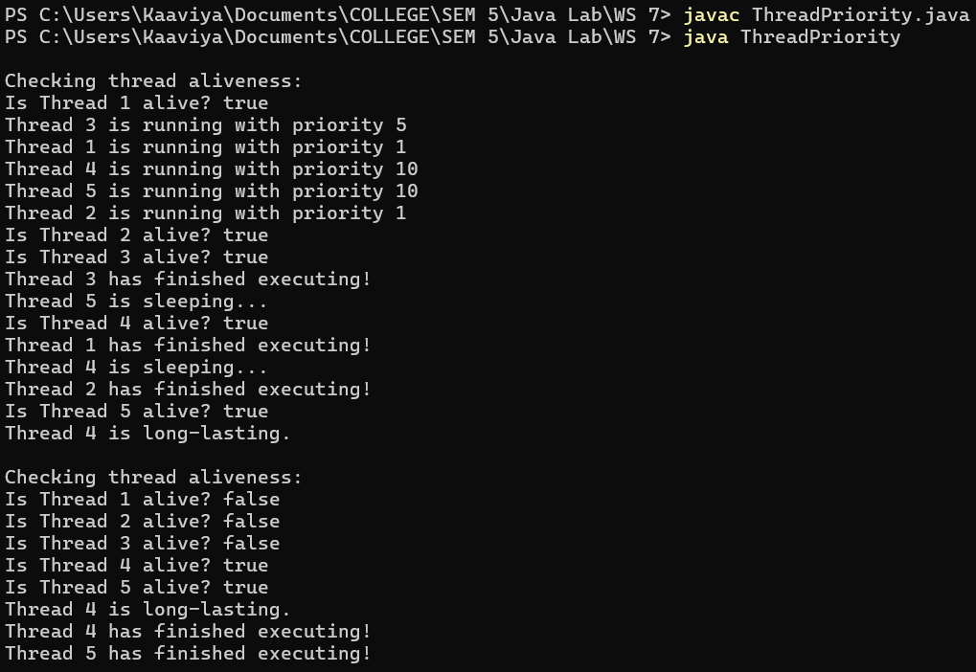

—----------------------------------------------------------------------------------------------------------------------------

4. Write a multithreaded program that calculates various statistical values for a list of numbers.
This program will be passed a series of numbers on the command line and will then create
three separate worker threads. One thread will determine the average of the numbers, the
second will determine the maximum value, and the third will determine the minimum value.
For example, suppose your program is passed the integers 90 81 78 95 79 72 85
Output:
The average value is 82
The minimum value is 72
The maximum value is 95
The variables representing the average, minimum, and maximum values will be stored
globally. The worker threads will set these values, and the parent thread will output the
values once the workers have exited.

class AverageThread extends Thread
{
int[] numbers;
double average;

public AverageThread(int[] numbers) {
this.numbers = numbers;
}

@Override
public void run() {
int sum = 0;
for (int num : numbers) {
sum += num;
}
average = (double) sum / numbers.length;
System.out.println("Average value: " + average);
}
}

class MinThread extends Thread
{
int[] numbers;
int min;

public MinThread(int[] numbers) {
this.numbers = numbers;
}

@Override
public void run() {
min = numbers[0];
for (int num : numbers) {
if (num < min)
min = num;
}
System.out.println("Minimum value: " + min);
}
}

class MaxThread extends Thread
{
int[] numbers;
int max;

public MaxThread(int[] numbers) {
this.numbers = numbers;
}

@Override
public void run() {
max = numbers[0];
for (int num : numbers) {
if (num > max)
max = num;
}
System.out.println("Maximum value: " + max);
}
}

public class StatisticalCalculator
{
public static void main(String[] args)
{
if (args.length == 0) {
System.out.println("Please provide numbers as command line arguments.");
return;
}

int[] numbers = new int[args.length];
for (int i = 0; i < args.length; i++) {
numbers[i] = Integer.parseInt(args[i]);
}

AverageThread avgThread = new AverageThread(numbers);
MinThread minThread = new MinThread(numbers);
MaxThread maxThread = new MaxThread(numbers);

avgThread.start();
minThread.start();
maxThread.start();

try {
avgThread.join();
minThread.join();
maxThread.join();
} catch (InterruptedException e) {
System.out.println("Thread was interrupted.");
}

System.out.println("All calculations are complete.");
}
}

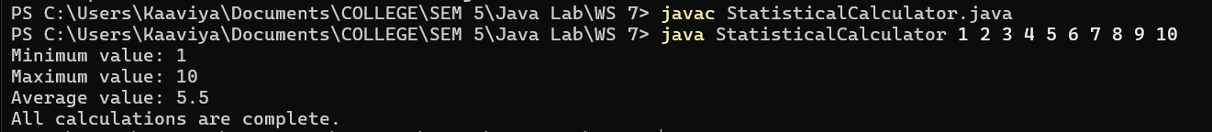

—----------------------------------------------------------------------------------------------------------------------------

5. Write a program for inventory problem, to illustrate the usage of synchronized keyword.

class Inventory
{
int items;

public Inventory(int initialItems) {
this.items = initialItems;
}

public synchronized void transact(String operation, int count)
{
if(operation.equals("add")) {
this.items += count;
System.out.println(count + " items added. Total items: " + items);
}
else if(operation.equals("remove")) {
if(count <= items) {
this.items -= count;
System.out.println(count + " items removed. Total items: " + items);
}
else {
System.out.println("No enough items to remove!");
}
}
else {
System.out.println("Invalid operation");
}
}

}

class InventoryManager extends Thread
{
Inventory inventory;
String operation;
int count;

public InventoryManager(Inventory inventory, String operation, int count)
{
this.inventory = inventory;
this.operation = operation;
this.count = count;
}
@Override
public void run() {
inventory.transact(operation, count);
}
}

public class InventoryProblem {
public static void main(String[] args)
{
Inventory inventory = new Inventory(10);
// Create threads to add and remove items
InventoryManager Thread1 = new InventoryManager(inventory, "add", 5);
InventoryManager Thread2 = new InventoryManager(inventory, "add", 10);
InventoryManager Thread3 = new InventoryManager(inventory, "remove", 7);
InventoryManager Thread4 = new InventoryManager(inventory, "remove", 15);
InventoryManager Thread5 = new InventoryManager(inventory, "add", 4);

Thread1.start();
Thread2.start();
Thread3.start();
Thread4.start();
Thread5.start();

try {
Thread1.join();
Thread2.join();
Thread3.join();
Thread4.join();
Thread5.join();
} catch (InterruptedException e) {
e.printStackTrace();
}
}
}

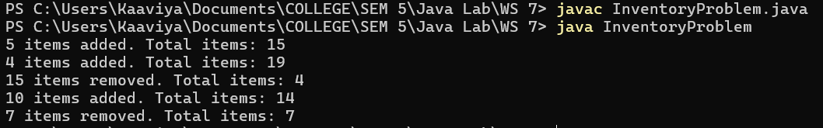

—----------------------------------------------------------------------------------------------------------------------------

6. Write a program for interthread communication process. In this they have three classes consumer, producer and stock.

class Stock {
int stock;

public Stock() {
this.stock = 0;
}

public synchronized void addStock(int count) {
this.stock += count;
System.out.println("Produced: " + count + " item. Current stock: " + stock);
notify(); // Notify a waiting consumer
}

public synchronized void removeStock(int count) {
while (stock == 0) {
try {
wait(); // Wait for stock to be available
} catch (InterruptedException e) {
Thread.currentThread().interrupt();
}
}
stock--;
System.out.println("Consumed: " + count + " item. Remaining stock: " + stock);
}
}

class Producer extends Thread{
Stock stock;

public Producer(Stock s) {
this.stock = s;
}

@Override
public void run() {
for(int i=0; i<10; i++) {
stock.addStock(1);

try {
Thread.sleep(100); //sleep for a while after producing
} catch (InterruptedException e) {
System.out.println("producer side: " + e);
}
}
}

}

class Consumer extends Thread{
Stock stock;

public Consumer(Stock s) {
this.stock = s;
}

@Override
public void run() {
for(int i=0; i<10; i++) {
stock.removeStock(1);

try {
Thread.sleep(150); //sleep for a while after consuming
} catch (InterruptedException e) {
System.out.println("consumer side: " + e);
}
}
}

}

public class InterThreadCommunication {
public static void main(String args[])
{
Stock stock = new Stock();

Producer producer = new Producer(stock);
Consumer consumer = new Consumer(stock);

producer.start();
consumer.start();
try {
producer.join();
consumer.join();
} catch (InterruptedException e) {
e.printStackTrace();
}

System.out.println("Production and consumption complete.");
}
}

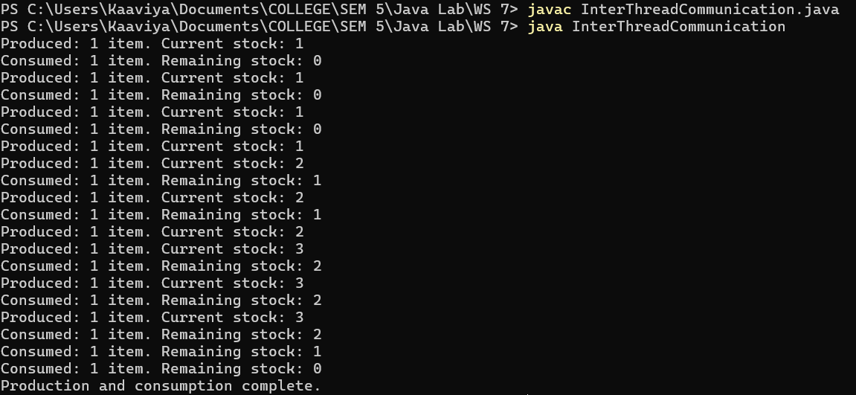

—----------------------------------------------------------------------------------------------------------------------------

7. Your English literature friend is very happy with the code you gave him. Now for his research, he used your application to find character frequency in many novels. For larger novels, the application takes a lot of time for computation. So he called you on a fine Sunday to discuss this with you. He wanted to know whether you can improve the speed of the application. You decided to modify the application by using multiple threads to reduce the computation time. For this, accept the number of counters or threads at the beginning of the problem and get the string for each counter or thread. Create a thread by extending the Thread class and take the user entered string as input. Each thread calculates the character frequency for the word assigned to that thread. All the counts are stored locally in the thread and once all the threads are completed print the character frequency for each of the threads. Create a class Main and test it.
Input and Output format:
Refer to sample Input and Output for formatting specifications.
Sample input and output:
Enter Number of Counters:2
Enter text for counter 1:FrequencyCounter
Enter text for counter 2:JavaTheCompleteReference
Counter 1 Result :
C:1 F:1 c:1 e:3 n:2 o:1 q:1 r:2 t:1 u:2 y:1
Counter 2 Result :
C:1 J:1 R:1 T:1 a:2 c:1 e:7 f:1 h:1 l:1 m:1 n:1 o:1 p:1 r:1 t:1 v:1

import java.util.Scanner;
import java.util.Map;
import java.util.HashMap;

class FrequencyCounter extends Thread
{
String text;
int counterID;
Map<Character, Integer> frequencyMap;

public FrequencyCounter(String text, int id) {
this.text = text;
this.counterID = id;
this.frequencyMap = new HashMap<>();
}

@Override
public void run() {
for (char c : text.toCharArray()) {
frequencyMap.put(c, frequencyMap.getOrDefault(c, 0) + 1);
}
}

public void printResult() {
System.out.print("Counter " + this.counterID + " Result : ");
for (Map.Entry<Character, Integer> entry : frequencyMap.entrySet())
{
System.out.print(entry.getKey() + ":" + entry.getValue() + " ");
}
System.out.println();
}
}

public class CharacterFrequencyCounter
{
public static void main(String[] args)
{
Scanner obj = new Scanner(System.in);
System.out.print("Enter Number of Counters: ");
int n = obj.nextInt();
obj.nextLine(); // Consume the newline character

FrequencyCounter[] counter = new FrequencyCounter[n];

for (int i = 0; i<n; i++) {
System.out.print("Enter text for counter " + (i + 1) + ": ");
String text = obj.nextLine();
counter[i] = new FrequencyCounter(text, (i+1));
}

for (FrequencyCounter c : counter) {
c.start();
}

for (FrequencyCounter c : counter) {
try {
c.join(); // Wait for the thread to finish
} catch (InterruptedException e) {
System.out.println("Thread interrupted.");
}
}

for (FrequencyCounter c : counter) {
c.printResult();
}

obj.close();
}
}





